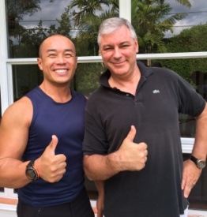 ***Laurent L.***

*“After several years without exercise, it became essential to me to get back in shape.*

*I had the pleasure and opportunity to meet a great professional.*

*Duc Long met me twice a week in the morning at 6:30 am at the Riviera Park of South Miami.  
   
He knew how to adapt a training program to my ability. He was very precise in his technique.  
  
Here are the qualities that I appreciated in him: he adapted each session to my pace, he constantly watched me perform the exercises for safety. The exercises were varied in each session but progressively more difficult in the long term according to my goal.*

*And I loved his sincere encouragement and genuine demeanor. And his targeted techniques achieve amazing results.*

*The advantage of his program: availability and exceptional listening.  
I thank him very much for his careful and constructive assistance.”*

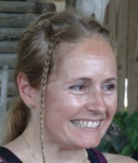 ***Sarah W.***

*“Cardio circuit training  
A coach to build and follow my session cardio training? It must be great but ... I'm going to have to do what he has planned and it is difficult to stop in the middle of a set because I cannot stand it. At first I regretted the first minutes, when he told me to continue while I was already exhausted.*

*But I did, I continued, I went far beyond what I could have done alone. It's simple – the level of difficulty of my sessions were the same as the level of difficulty of one of Duc Long’s warm ups. I panicked a little, but thanks to him, his support, his explanations and his constant attention, I managed to do what he had expected. The training is complete, it is varied, it is interesting to understand how to work my body and achieve what I can do. I learn to breathe better during exercise. Today I want more and I cannot see the gym as an unknown and hostile terrain.”*

** ***Richard T.***

*"Observation, gentleness and persuasion are the words which best summarize Duc Long's coaching.*

*He is a connoisseur of the physiology and anatomy, and is an especially, attentive observer.*

*He is able to exactly determine exactly not only the needs, but also the possibilities of the trained person".*

***Isabelle R.***

*“I have been working with Duc Long for 4 months, two to three times a week.*

*I really enjoy his coaching method. He knows how to motivate me, he pushes me. He makes his coaching fun and different every time which allows me not to be bored.*

*He advises me on a diet, makes sure I eat properly to reach the best results very fast.*

*I really recommend Duc Long as a personal coach. He really cares about his clients and really personalizes his coaching to our different needs.”*

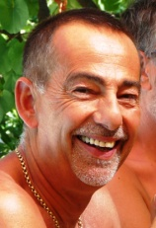 ***Marc M.***

*“I can assure you that he has always been a coach who concisely and specifically explains all of the movements that I wanted to do in order to avoid bad positions that could hurt me.*

*Similarly he has always shown great patience and instruction.  
In addition, his user-friendly approach and his encouraging and professional demeanor allowed me to enjoy a sport for which I had very little affinity.  
He knew how to make the gym pleasurable and essential for me.*

*I would like to have continued with him, and I miss his guidance and advice…” (Marseille)*

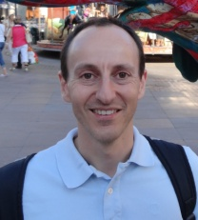 ***Xavier M.***

*“I had the opportunity to be trained by Duc Long three times a week from September 2005 to June 2007 and during the first quarter of 2009.  
   
His advantages? He researched the constantly changing bodybuilding techniques and put them into practice with great efficiency.  
I enjoyed it very available and anxious to make me share his knowledge.  
   
He was always available to answer my questions and he always wanted to share his knowledge by its dynamism.  
Technical advice and safety were a real added value to my training.  
   
And I am very sorry that I don’t live in the same city as him because I have not found a teacher of its value since his departure.  
My goal was to gain muscle mass. And thanks to him, I managed to gain 7kg of muscle!”*

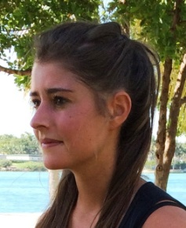 ***Giuliana V.***

*“I followed a program 2-3 times a week at South Point Park in Miami Beach for 3 months with Duc Long.  
  I benefited from a specialized program that took onto account my physical background and the results I was looking for. I also took advantage of monitoring and Duc Long's advice about diet and exercise to maximize results outside the sessions.*

*Thanks to the patience and professionalism of Duc Long I could quickly see the results both physically and in training as I had never done any sports before.*

*I remember in particular his kindness, and Duc Long’s pedagogy has given me an appreciation for exercise. I was very nervous to start this program and I recommend his services to anyone wanting to get in shape or simply wanting to adopt a healthier lifestyle.”*

***Peter C.***

*“As I was approaching fifty, my goal was to get back in shape in order to run a half-marathon and lose weight.  
I reached my goals without injury after several months thanks to personalized training adapted to my ability with attention to safety.   
I owe a big thank you to the very professional Duc Long who got me physically and mentally fit.*

*Now I would like to try the full marathon this year!!!”*

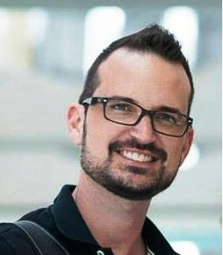 ***Jeremy M.***

*"Training with Duc Long is an illuminating experience customized to my needs.*

*Too often personal trainers take a "one-size-fits-all" approach to training and fail to personalize the experience or provide guidance outside of the gym. Duc Long truly cares about me - he desires that I progress in a way that is efficient and safe. He was always careful to guide me in the proper range of motion and technique for each exercise, and he would gradually increase the level of difficulty as I was ready.*

*He provided clear workout plans and easy-to-follow diet advice.*

*The results speak for themselves - I look better and feel healthier than I ever have before thanks to the attention of Duc Long."*

***Antonella C.***

*“Sincerely, Duc Long Dinh is the best coach I’ve ever had. I decided to get in good shape and to lose weight a few months ago. We discussed my goals, Duc Long analysed my data (weight, measurement etc) and he made a plan.*

*I’m not very fond of sports in general but the sessions went so fast. I worked very hard with pleasure even if it was sometimes difficult. Duc Long explained all the exercises very well and corrected my positions so that my body worked efficiently and I couldn't get hurt. He adapted the exercises to my energy level and every session was different. He motivated me when my motivation was down and gave me very good advice.*

*Duc Long likes to train people and that makes all the difference with other trainers. He enjoys working out with his students.  So it was never boring. Moreover I have more energy and* ***have started my*** *dieted. I lost the weight I wanted and I feel so well now.”*

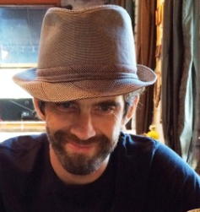 ***Kerredine Y.***

*I started to train with Duc Long two years ago with my girlfriend.  
We have very different levels of fitness and experience. I have been working out assiduously for the past 10 years (with and without trainers), having a solid condition and technique, whereas she was relatively out of shape and inexperienced technically speaking. Still, we wanted to train together to optimize our time and do this as a couple.  
   
It was challenging to find a personal trainer who could accommodate our needs and design simultaneous training programs with two completely different profiles.  
  
Duc Long has managed to develop a tailor made program for us, satisfying our individual and mutual goals.   
He has managed to take me to the next level of weight, fitness with very advanced techniques while teaching me how to integrate nutrition into my program. I have learned new breathing skills and corrected bad habits that I had accumulated for years.  
Meanwhile, my girlfriend has gotten back in shape and acquired a newfound motivation to train and push herself.  
  
I am especially grateful to Duc Long for bringing a special focus on stretching, breathing and nutrition to our training, influencing our lifestyle rather than just training.  
His calmness and attention to detail as well as his versatility make him a very unique personal trainer, definitely the best I've had and our official family wellness consultant.  
Thank you Coach Duc Long!*

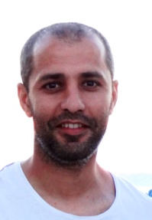 ***Mohamed M.***

*I followed customized courses in a gym and I was coached by Duc Long in cardio and weight training.*

*I have fond memories of those meetings and I confess that today I have given up working out. (Marseille).*

*I have not found one person who is attentive to my needs and is able to adapt a program to my whole being like Duc Long.He was an excellent teacher.*

*His encouragement allowed me to push myself and go beyond my abilities.*

*Duc Long knows how to make the best of each individual and his passion for sports coaching gives you an incentive to invest in yourself.*

*He is very attentive to detail in order to prevent possible injury and he also made me change my way of learning about the field of nutrition and health.*

*I highly recommend you try it, you will try it and adopt it! »*

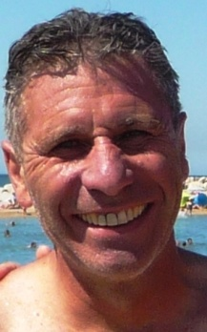 ***Dominique D.***

*I was fortunate to have Duc Long’s advice on the steps necessary to get in shape.  
I am 60 years old and despite being athletic, I needed to build my core strength.  
Duc Long gave me professional expertise and personal attention. I am very satisfied.*

***Franck M.***

*“I greatly appreciate the professionalism of Duc Long, who differs from other coaches.  
His advantages are: mastery, monitoring, constant advice without arrogance, flexible strength training and understanding.”*